Western Pacific Univesirty
CMN224/CMP224 Software Engineering – Week 5
Lab 4: Architecture & UML for Your Client
Project: Kina Ridge Primary School Fee – Tracking System
Name: Justin Albert
ID: 00110
Part A: Answer the six (6) following questions
No | Question | Your decision, and the requirement that forced it.
1 | What are the major parts of the system? | The system consists of five main components: User Interface, Application Logic, Data Access, Local Database, and Backup/Audit. Together, they manage payments, balances, user access, records, and secure data storage.
2 | How do the parts communicate? | The User Interface connects to the Application Logic, which validates transactions and uses Data Access to manage the local database. This separation reduces errors and keeps financial processing independent from the display.
3 | Where does the data live? | Student, fee, and payment records will be stored in a local SQLite database with regular backups. This ensures data protection and allows payments to continue even when the internet is unreliable.
4 | Where does each part physically run? | The system will run on the school’s existing office laptop, with a printer for physical receipts. This setup avoids the need for a dedicated server.
5 | How is access controlled, and where is that enforced? | Users must log in to access financial records, with role-based permissions controlling data entry, editing, and viewing. This ensures that only authorized staff can access sensitive financial information.
6 | What happens when it fails — power loss, no signal, duplicate sync? | Saved transactions will remain in the local database after power outages, and essential records can be entered without internet access. Daily backups will protect data from laptop failures, while local storage avoids duplicate-sync problems.

Part B: Choose an architectural pattern
Pattern chosen (or blend): Offline-first + Layered Architecture

The Fee-Tracking System for Kina Ridge Primary School will implement an offline-first approach along with a layered architectural design. This is appropriate since the school faces weekly power interruptions and reliable Wi-Fi access is not assured. The system will consequently save key student, fee, and payment details in a local database on the current office laptop. Employees will have access to log payments and verify balances without relying on constant internet connectivity. The tiered architecture will distinguish the user interface, application logic, and data access, facilitating easier system maintenance and testing. Regular backups will minimize the risk of data loss if the laptop malfunctions. A conventional client-server model featuring a single central online database was dismissed due to the lack of dependable continuous network access at the school. The offline-first strategy aligns more effectively with the school's real operating conditions.

Part C: Draw the package diagram
PlantUML version Diagram 1

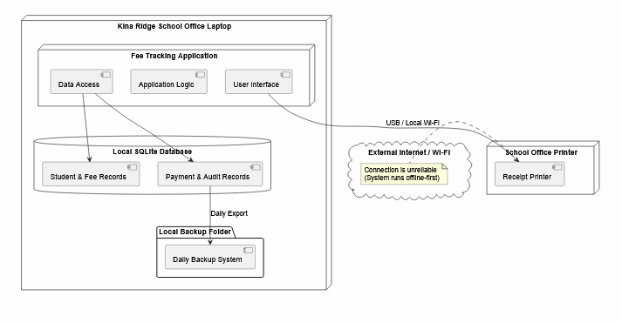

Part D: Draw the deployment diagram
Show every device your system runs on, what is installed on each, and the link between them. This is the diagram that exposes PNG delivery risk, so be honest about the network.
Must appear on your diagram | Check
Every physical device (laptop, phone, office PC, printer) | Yes. Included as node "Kina Ridge School Office Laptop", the node "School Printer," and the cloud "Internet / Wi-Fi."
What software component sits on each device | Yes. Placed the components of the "Fee Tracking Application" (UI, Logic, Data Access) within the primary laptop node.
Where the data is stored on each device | Yes. The "Local SQLite Database" and "Local Backup" folder are contained within the physical limits of the laptop.
The link between devices, labelled with how and how  often it is available | Yes. The printer connection is clearly marked as USB / Local. The Internet connection is a dotted line marked as Optional link.
A note on what still works while that link is DOWN | Yes. Inserted a note to the right of the Internet block indicating that local entry, balances, and receipt printing operate smoothly without an internet connection.

PlantUML version Diagram 2
